**Scottish Quality and Safety Fellowship**

**Programme Outline**

**Cohort 17**

**Contents**

Introduction 2

The Fellowship Programme 3

Aims 3

Objectives 3

Participation 3

Programme Delivery 4

Cohort 17 Model 5

Curriculum 6

Provisional Timetable: 8

Funding 10

# Introduction

The Scottish Quality and Safety Fellowship was initially developed to support the delivery of the Scottish Patient Safety Programme (SPSP) by developing clinical leaders with the advanced knowledge, technical ability and essential leadership skills to deliver improved health and healthcare for the people of Scotland.

Over the intervening 16 years, Fellows have broadened their contribution to Quality and Safety Improvement activities reflecting the wider national ambitions described in Scotland’s 2020 Vision.

The Scottish Quality and Safety Fellowship Programme is managed by NHS Education for Scotland (NES), working in partnership with Healthcare Improvement Scotland and NHSScotland.

Cohort 17 of the Scottish Quality & Safety Fellowship will be building on the successful 16 years, during which over 427 Fellows have taken part in a tailored programme to enhance their individual capacity for leadership in improvement.

All Fellows require the explicit, strong support of their sponsoring organisation. Organisations must support the leadership of a significant improvement project lead by the Fellow, co- develop the Fellow as an improvement champion with the Fellowship coaching team and enable full participation in all aspects of the programme and in applying their skills in their workplace. It is expected that following completion of the programme Fellows will continue to devote a significant part of their work to improving the quality and safety of care.

The Fellowship promotes active collaboration with other organisations or agencies sharing similar aims within Scotland, the UK and internationally.

# The Fellowship Programme

## Aims

The Scottish Quality and Safety Fellowship aims to develop and strengthen clinical leadership and improvement capability in NHSScotland.

## Objectives

To develop clinical leaders capable of improving the Quality and Safety of health and healthcare for the people of Scotland.

To enhance knowledge of the science and methods for improvement amongst clinicians who have enthusiasm, experience and skills to:

* + support the development of safety programmes
  + spread improvements both within their organisation and nationally.
  + establish a learning support network for transformational leadership for Quality Improvement.
  + complement wider improvement capacity building programmes within NHSScotland while supporting NHSScotland workforce development.
  + strengthen cooperation and collaboration with important overseas healthcare providers in Europe and beyond.

## Participation

The Fellowship is open to healthcare staff who currently undertake clinical practice and have a direct influence on improving the delivery of safe patient care, as well as staff in clinical professions (e.g. medical, nursing, pharmacy, AHP, healthcare scientists, ambulance) who do not currently deliver hands-on care but do have a role in improving patient care or safety.

Individuals participating in this programme will need the full support of their employing organisation and explicit sponsorship from their Line Manager and Chief Executive.

Participants should be able to demonstrate an interest in service improvement and should already be actively involved with patient safety in their workplace. A full Person Specification is available as part of the Application Pack for the Fellowship.

Please note that there is the expectation that Fellows will be involved in supporting the Healthcare Quality Strategy at local and national level after completing the Fellowship programme. This may include mentoring, technical advice, teaching and other quality improvement activities. We expect sponsoring organisations to release (Scottish) Fellows for up to 10 days per year to support national level work to support out National Quality Strategy for five years following completion of the Fellowship Programme.

## Programme Delivery

The Fellowship is built and delivered using principles of adult and action learning and delivered using a blended learning style.

The programme is delivered over a period of approximately 10 months, commencing in October 2025.

All Fellows are required to undertake their own improvement project as part of the programme.

The delivery of the programme will be a combination of:

* Self-directed distance learning supported by teleconference and web-based communication, for example Microsoft Teams & the Moodle learning platform
* Mentoring delivered by previous Fellows, or others working in patient safety or quality improvement roles locally
* Formal education delivered through a series of 3-day residential courses
* A variety of workshops, networking events and project surgeries
* Additional educational and networking opportunities

Fellows will be expected to present a report of their learning and achievements to their sponsoring organisations. They may also be asked to submit reports of their work for presentation at national and international conferences and peer-reviewed publications.

Please see pages 5-8 for the SQSF Cohort 17 Delivery Model, Curriculum and Driver Diagram.

**Cohort 17 Model**

## Curriculum

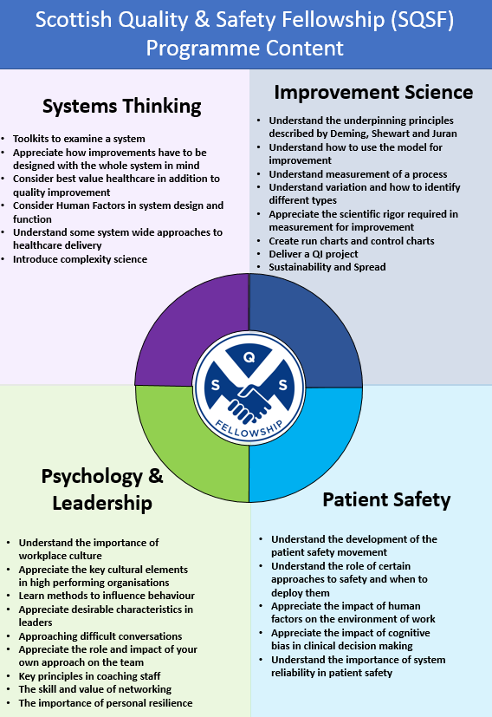

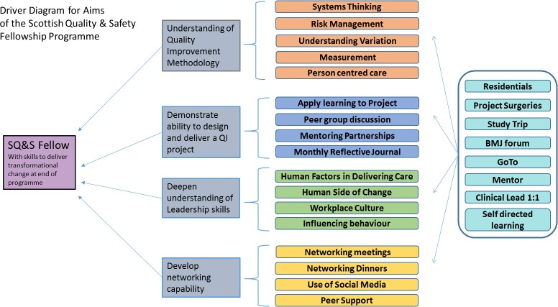

# Provisional Timetable:

|  |  |  |  |  |
| --- | --- | --- | --- | --- |
| **Date** |  | **Activity** |  |  |
| 9 October 2025 | 09:30 – 11:00 | **Virtual Module 1**  Remote access |  |  |
| 21-23 October 2025 | 3 Days | **First Residential Workshop** Venue to be confirmed (Edinburgh, Glasgow or Dundee) |  |  |
| 6 November 2025 | 09:30 – 11:00 | **Virtual Module 2**  Remote access |  |  |
| 13 November 2025 | 15:00 – 16:30 | **Virtual Module 3**  Remote access |  |  |
| 25-27 November 2025 | 3 days | **Second Residential Workshop**  Venue to be confirmed (Edinburgh, Glasgow or Dundee) |  |  |
| 15 January 2026 | 09:30 – 12:00 | **Virtual Module 4 – Virtual Project Clinic**  Remote access |  |  |
| 22 January 2026 | 09:30 – 12:00 | **Virtual Module 5 – Virtual Project Clinic**  Remote access |  |  |
| 19 February 2026 | 09:30 – 11:00 | **Virtual Module 6**  Remote access |  |  |
| 3-5 March 2026 | 3 days | **Third Residential Workshop**  Venue to be confirmed (Edinburgh, Glasgow or Dundee) |  |  |
| 26 March 2026 | 1 day | **Project Surgery 1**  Venue to be confirmed (Edinburgh, Glasgow or Dundee) |  |  |
| 31March – 2 April 2026 | 3 days | **Spring Sessions - Content Day and Project Surgery 2 and 3**  Venue to be confirmed (Edinburgh, Glasgow or Dundee) |  |  |
| 9April 2026 | 09:30 – 11:00 | **Virtual Module 7 – Visualising Data & Pre-Forum Preparation**  Remote access |  |  |
| TBC | 3 Days | **International Forum on Quality and Safety in Healthcare**  Venue TBC |  |  |
| 7 May 2026 | 09:30 – 11:00 | **Virtual Module 8 – Post-Forum Teach Back 1**  Remote access |  |  |
| 14 May 2026 | 09:30 – 11:00 | **Virtual Module 9 - Post Forum Teach Back 2**  Remote access |  |  |
| 6 August 2026 | 09:30 – 11:00 | **Virtual Module 10 – Planning session for celebration day**  Remote access |  |  |
| 1 -3 September 2026 | 3 Day | **Networking Day and Fourth Residential Workshop**  Venue to be confirmed (Edinburgh, Glasgow or Dundee) |  |  |
| September 2026 –  March 2027 |  | **Fellows’ Field Trips** To be arranged by Fellows |  |  |
| 11th March 2027 |  | **Virtual Module 11 - Virtual study trips catch up**  Remote access |  |  |
| 1st April 2027 |  | **Virtual Module 12 - Virtual study trip network day planning**  Remote access |  |  |
| September 2027 TBC | 1 Day | **Fellowship Study Trip Networking Day**  Venue TBC |  |  |

Fellows must be able to attend all days of all Residential Workshops as well as the Networking Event and complete both the group and individual field trips.

All Fellows must present at one of the Project Surgeries and are strongly advised to attend all Project Surgeries if possible.

All Fellows are expected to attend 80% of remote 1.5-hoursessions throughout the programme as well as other opportunities available as per individual needs.

# Funding

Participants will need the full support of their employing organisation and explicit sponsorship from their Line Manager and the Chief Executive.

All International Fellows require funding by their own healthcare system at a cost of 15,000. Costs covered by this include (but are not limited to):

• Venue, accommodation and faculty for residential courses and field trips.

• Attendance by any external or international faculty.

• Set reading list.

• Cost of maintaining and improving Fellowship online resources.